ARE YOU HEADING FOR
P REVENTABLE BLINDNESS
FIND OUT WITH A FREE SCREENING
At the Lions district
11-A1 convention:
Sheraton Detroit Metro Airport Hotel
8000 Merriman Rd, Romulus, Michigan 48174

April 19, 6 pm – 9 pm
April 20, 8 am – 5 pm
April 21, 9 am – 12 pm

Diabetic Retinopathy
Is a leading cause of blindness in the USA. This vision loss can be preventable.
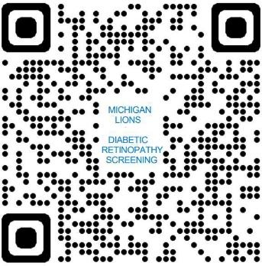
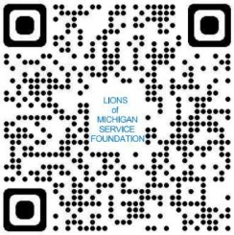
Lions Clubs International
LEARN ABOUT DIABETIC RETINOPATHY SCREENING
LEARN ABOUT LIONS OF MICHIGAN SERVICE FOUNDATION
Is the World’s largest Service organization with 1.4 million members in over 200 countries.

